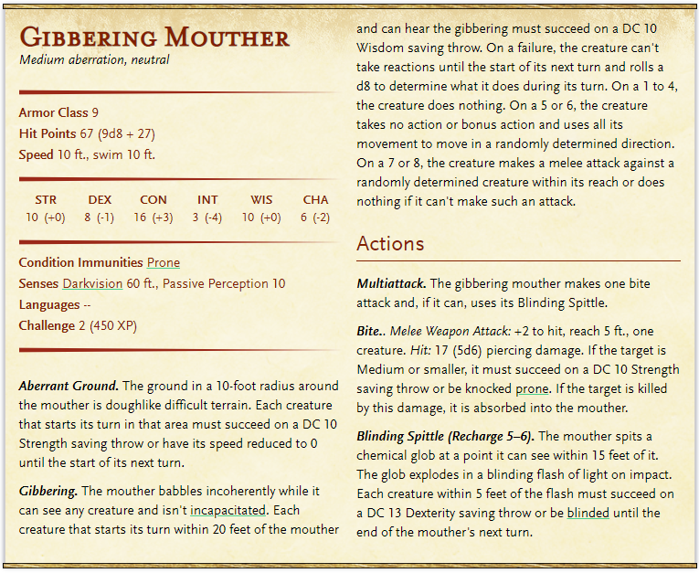Monsters – Axlivan 1

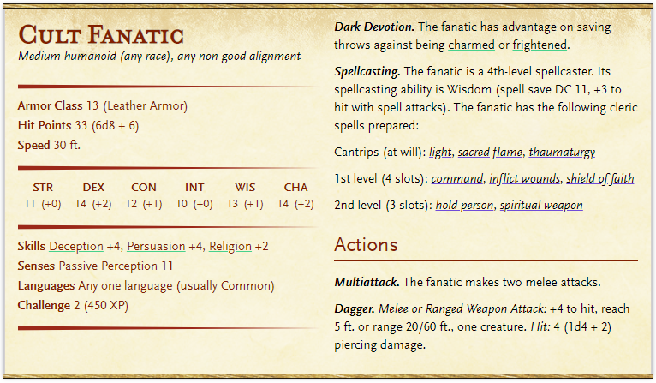

Treasure: 14 GP + 8 SP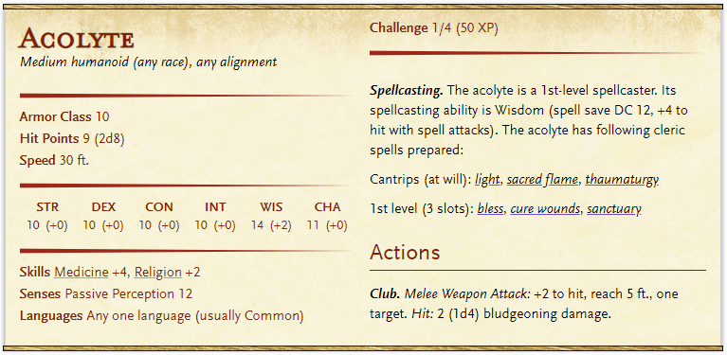Treasure: 21 GP + 18 CP

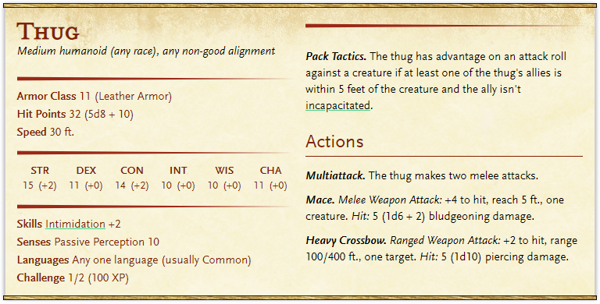

Treasure: 4 GP + 12 CP